(Baxter Labs) Bexter Labs produces three products: A, B, and C. Bexter can sell up to 2000 units of product A, up to 2500 units of product B, and up to 800 units of product C. Each unit of product C uses two units of A and three units of B and incurs $5 in processing costs. Products A and B are produced from either raw material 1 or raw material 2. It costs $6 to purchase and process one unit of raw material 1. Each processed unit of raw material 1 yields two units of A and three units of B. It costs $3 to purchase and process a unit of raw material 2. Each processed unit of raw material 2 yields one unit of A and two units of B. The unit prices for the products are: A, $5; B, $4; and C, $25. The quality levels of each product are: A, 8; B, 7; and C, 6. The average quality level of the units sold must be at least 7. Determine how to maximize Bexter’s profit.

**Discussion: -**

If we understand how the products were produced it is easy to solve the problem. Please refer to the snapshot given below. We can understand from problem that Bexter labs produces three products in two steps. In first step it produces two products using raw material and in second step it used product A and product B to produce product C.

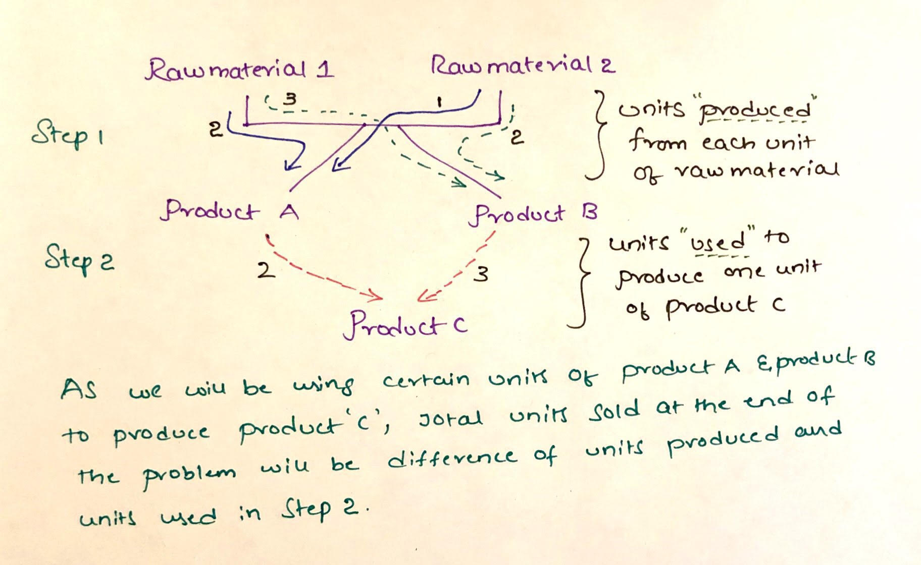

Our objective is to maximize the profit, which means we need to know how many products were sold by Bexter. In order to find the production quantity, we need to know the raw material used to produce that particular product. So, we should consider units of raw material used for production of product A and B, units of product C produced as decision variables.

**Mathematical Model: -**

*Parameters (Inputs):*

*Decision Variables:*

*Calculated Variables:*

*Objective:*

*Constraints:*

As we have a cap for units that can be sold we will be writing constraint # 2. To maintain average quality, we used constraint # 3.

*Excel Implementation:* Please find the attached spreadsheet for solution.



